**CATIA VBA中Measurable测量方法的应用**

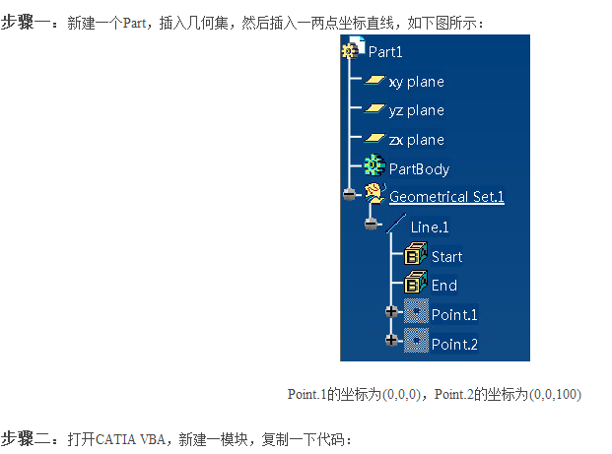

Sub CATMain()

    Dim partDocument1 As PartDocument

    Set partDocument1 = CATIA.ActiveDocument

    Dim part1 As Part

    Set part1 = partDocument1.Part

    Dim hybridBodies1 As HybridBodies

    Set hybridBodies1 = part1.HybridBodies

    Dim hybridBody1 As HybridBody

    Set hybridBody1 = hybridBodies1.Item(1)

    Dim hybridshapes1 As hybridshapes

    Set hybridshapes1 = hybridBody1.hybridshapes

    Dim hybridshape1 As hybridshape

    Set hybridshape1 = hybridshapes1.Item(1)

    Dim TheSPAWorkbench As Workbench

    Set TheSPAWorkbench = CATIA.ActiveDocument.GetWorkbench("SPAWorkbench")

    Dim NewMeasurable

    Set NewMeasurable = TheSPAWorkbench.GetMeasurable(hybridshape1)

    Dim Direction(2)

    Erase Direction

    NewMeasurable.GetDirection Direction

    MsgBox Join(Direction, ",")

End Sub

